CALL FOR COMMUNICATIONS

INTERNATIONAL CONFERENCE

DIGITAL HUMANITIES

Artificial intelligence and artistic and literary creation

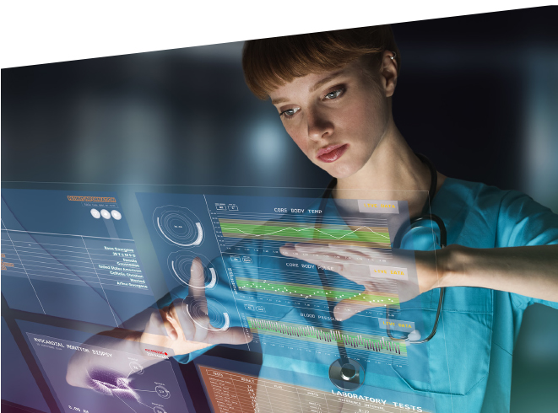

Conference organized by
Mourad Abed, Amos Fergombé, Arnaud Huftier and Nikoleta Kerinska

(Université Polytechnique Hauts-de-France - Valenciennes)

24th and 25th of November 2022

The aim of this second conference, following the one organized on 7th and 8th of October 2021, is to pursue, starting from the heritage of humanism, as a movement and a current of thought stemming from the Renaissance, the uses of the digital in the process of redefining the Human and the Humanism. What is the place of the human being while confronted to the promised alterations and the technological and ecological challenges? How does the change induced by digital and computational models lead to a reconsideration of the individual and the collective, and open the way to new practices (from writing to reception) of literary and artistic works? What approaches do the disciplines of the humanities take and what can they ‘do’ in a sometimes blurred ecosystem? How do literary and artistic works establish new narratives, “shaken up” and modified by the irruption of technologies?
From an interdisciplinary and transdisciplinary perspective, this would mean analysing and reconsidering works of art, narratives, imaginaries and representations, their constructions/deconstructions, and the ethical issues this raises. This consideration has led to a new way of conceiving protocols and new applications for the cultural and creative industries, industrial environments, and health fields. The contemporary techno-scientific mutations of digital technology and the emergence of new forms of intelligence, known as artificial intelligence, question the future of the human being, the relationship to artistic and literary creation, and the very status of the work of art. They augur the appearance of new forms of cooperation: between human beings and machines on the one hand, and between human beings themselves on the other. This evolution leads to a paradigm shift at the heart of our society's technological and conceptual advances, with a different definition of the human in view, a hyperhuman whose design seems to be taking shape.
This second symposium, to be held on the 24th and the 25th of November 2022, will be devoted to intelligent devices, the use of artificial intelligence by artists and in literary and artistic works, through anthropomorphic machines. Should/could human intelligence overtake technology?
We will look at creative practices, the process of creating works based on artificial intelligence, ethical and societal issues, intellectual property, and the concept of creativity.
How can algorithms and machine learning take over the intuition and the creative process? What are the perspectives of the gestures in art, of the style, but also of the forms of sensibility and sensorially in the face of a work endowed with artificial intelligence? How can we grasp the cultural impact of AI and reflect on the sensitive universe of the artificial languages it engages. How the computer program, bearer of a formal logic, has opened the way to simulations and simulacra of reality but also to the realization of works deployed in the metaverse and stemming from the blockchain certificate of authenticity, from the computer code of the NFT, the “non-fungible token”, which have established themselves as dictating the behavior of the art market. Such a mutation of art invites us to question the economic and political stakes of the crypto-currencies/crypto-arts used to determine the value of art in the metaverse, the lucrative and speculative dimension of counterfeit works.
We could be interested in the traceability and authenticity of works for the very reason of their infinite “reproducibility” (Walter Benjamin). Their greater, often instantaneous, diffusion makes the notion of intellectual and moral property obsolete, unless one has the legal means to trace authenticity and defend one’s rights. How has profusion replaced diffusion? This approach can also be considered by calling upon those artistic movements, that have set milestones in a quasi-machinic exploration.
The conference is envisioned in a transdisciplinary perspective, in order to cross the approaches resulting from the human sciences with those resulting from the computer sciences. It will welcome researchers from these disciplines as well as artists and creators.
The Digital Humanities conference is part of the “DeScripto - Praxis des écritures et des imaginaires” research unit of LARSH, who aims, among other things, at the theoretical and practical study of the presentation/representation devices of all the forms of writing or enunciation (linguistic, iconic, vocal, corporeal signs) with or without aesthetic value. The DeScripto Research Unit intends to question the writing and the uses of the digital, starting with the processes of ex-pression, staging, transmediality, transgenericity or translation.
As an opposition to the usual compartmentalization between disciplines, the project initiated around digital humanities proposes to examine a fruitful transdisciplinarity by showing how the research work of the digital sciences will be nourished by the questions raised by the humanities and social sciences, and vice versa. The aim is to articulate originally and ambitiously the problems and methods of the SHS and the digital sciences, to elaborate, interpret, analyze socially and technically the connected human being, in permanent interaction with his objects, smart-devices, digital assistants, etc., and to analyze the making of literary and artistic works by the digital.
Proposals (title, abstract, short bio-bibliography, 3000 characters maximum) must be sent by 30th of October 2022 to: amos.fergombe@uphf.fr or nikoleta.kerinska@uphf.fr

